INSTRUCTIONAL PACKAGE

Effective Term: Fall 2014 (201410)

COURSE PREFIX: TUF 220 COURSE TITLE: Special Topics in Turf Management

CONTACT HOURS: 3 CREDIT HOURS: 3

RATIONALE FOR THE COURSE: Observe the students in a real world setting that challenges the skills and knowledge obtained in the classroom.

COURSE DESCRIPTION: This course will include special topics in the area of Turf Management

PREREQUISITES: TUF 172

REQUIRED MATERIALS: None

ADDITIONAL REQUIREMENTS: None

TECHNICAL REQUIREMENTS:None

Attention HGTC Students:
The faculty and administration of HGTC are committed to enhancing your learning experience at the College through improved methods of instruction and support services. For information on Student Support Services or questions about your curriculum program please refer to your Wavenet Homepage.
STUDENT COURSE LEARNING OUTCOMES
Live project that allows students to apply their skills and gain knowledge in the preparation of a golf course for a major event.

REQUIRED COURSE MEASURES/ARTIFACTS
Work skills Attendance
Attitude.

EVALUATION OF REQUIRED COURSE MEASURES/ARTIFACTS
Student will have daily and week-end evaluation from both the attending Professor and the industry representative.

GRADING SYSTEM:
90% = A
80-90% = B
70-79% = C
60-69% = D
Below = F

Grades earned in courses impact academic progression and financial aid status. Before withdrawing from a course, be sure to talk with your instructor and financial aid counselor about the implications of that course of action. Ds, Fs, Ws, WFs and Is also negatively impact academic progression and financial aid status.

The Add/Drop Period is the first 5 days of the semester for full term classes. Add/Drop periods are shorter for accelerated format courses. The following week of the semester is Financial Aid Attendance Verification period. You must attend at least one meeting of all of your classes during that period. If you do not, you will be dropped from the course(s) and your Financial Aid will be reduced accordingly.

The Student Success and Tutoring Center (SSTC)
The SSTC offers to all students the following free resources:
- Academic coaches for most subject areas, Writing Center Support, and college success skills
- On-line student success and academic support resources
- 24/7 online academic tutoring assistance (access in WaveNet)
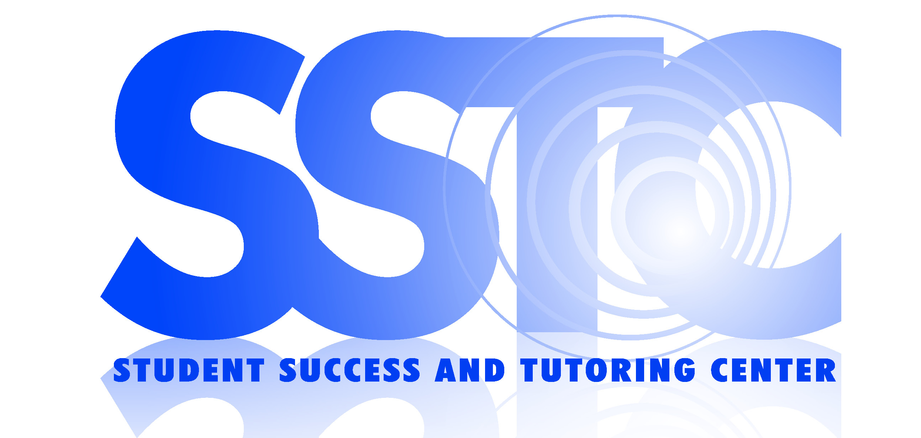
- 24/7 Online Resource Center (ORC)
- Campus2Campus Virtual Appointments
- Tips and tricks for college life, studying, and learning (Facebook: hgtcsstc)
- Other student resources and academic support
  - Resource guides to improve college success skills
  - Science models & other supplemental tools and textbooks
  - Workshops on college success skills and citation styles
  - Study Skills, Test Anxiety, Time Management, etc.
  - APA, MLA, and Preventing Plagiarism
  - Check the EVENTS calendar in WaveNet for more information!
Visit the SSTC website: www.hgtc.edu/sstc and visit the student services tab in your WaveNet account to schedule appointments using TutorTrac. For more information, call: SSTC Conway, 349-7872; SSTC Grand Strand, 477-2113; and SSTC Georgetown, 520-1455. Room locations and Live Chat is available on the SSTC website.

Student Information Center: WaveNet Central (WNC)
WNC offers to all students the following free resources:
- Getting around HGTC: General information and guidance for enrollment!
- Use the Online Resource Center (ORC) for COMPASS support, technology education, and online tools
- Drop-in technology support or scheduled training in the Center or in class

- In-person workshops and online tutorials are available for:
  - D2L & WaveNet,
  - Microsoft Office Word, PowerPoint and Excel,
  - Basic Computer Skills,
  - Budgeting your Money, and more.
  - Check the EVENTS calendar or the WNC Online Resource Center for more information!
- Additional services such as reviewing Degree Works, scheduling tutoring, or scheduling testing center appointments, scanning and uploading documents, etc.
Visit the WNC website: www.hgtc.edu/wavenetcentral. Live Chat and Center locations are posted on the website. Or please call one of the following locations: WNC Conway, 349-5182; WNC Grand Strand, 477-2076; and WNC Georgetown, 520-1473. View tips and tricks for college life, personal development and technology learning on their Facebook page (Facebook: hgtcwnc).
INSTRUCTOR’S PERSONAL INFORMATION SHEET
*Instructor’s Name:

**Office Location:

**Office Telephone Number:

*E-mail Address:

Home Telephone Number: (Optional)

Classroom Decorum: (Optional)

*Attendance Policy: School Policy Enforced

*Tardy Policy: Being late is disruptive to all who are on time. If it becomes a habit you will not be allowed in class and considered absent.

*Make-up Test Policy: Non-Negotiable except in case of emergency

*Required Information
**Full-Time Faculty Only

